ASSIGNMENT 5 (DBMS)

Customers
customer_id (INT, PRIMARY KEY)
name (VARCHAR)
dob (DATE)
city (VARCHAR)
account_type (VARCHAR)

Accounts
account_id (INT, PRIMARY KEY)
customer_id (INT, FOREIGN KEY REFERENCES
Customers(customer_id))
balance (DECIMAL)
account_type (VARCHAR)
branch_id (INT, FOREIGN KEY REFERENCES Branches(branch_id))

Transactions
transaction_id (INT, PRIMARY KEY)
account_id (INT, FOREIGN KEY REFERENCES
Accounts(account_id))
amount (DECIMAL)

transaction_type (VARCHAR) -- (‘Deposit’, ‘Withdrawal’)
transaction_date (DATE)
Branches
branch_id (INT, PRIMARY KEY)
branch_name (VARCHAR)
city (VARCHAR)

Loans
loan_id (INT, PRIMARY KEY)
customer_id (INT, FOREIGN KEY REFERENCES
Customers(customer_id))
amount (DECIMAL)
loan_type (VARCHAR) -- (‘Home’, ‘Car’, ‘Personal’)
status (VARCHAR) -- (‘;Approved’, ‘Pending, ‘Rejected’)

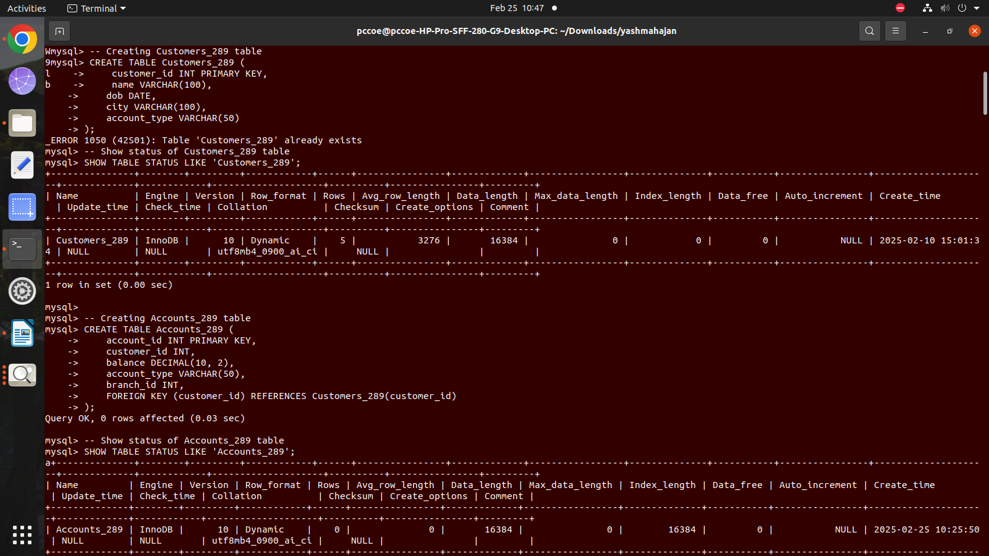

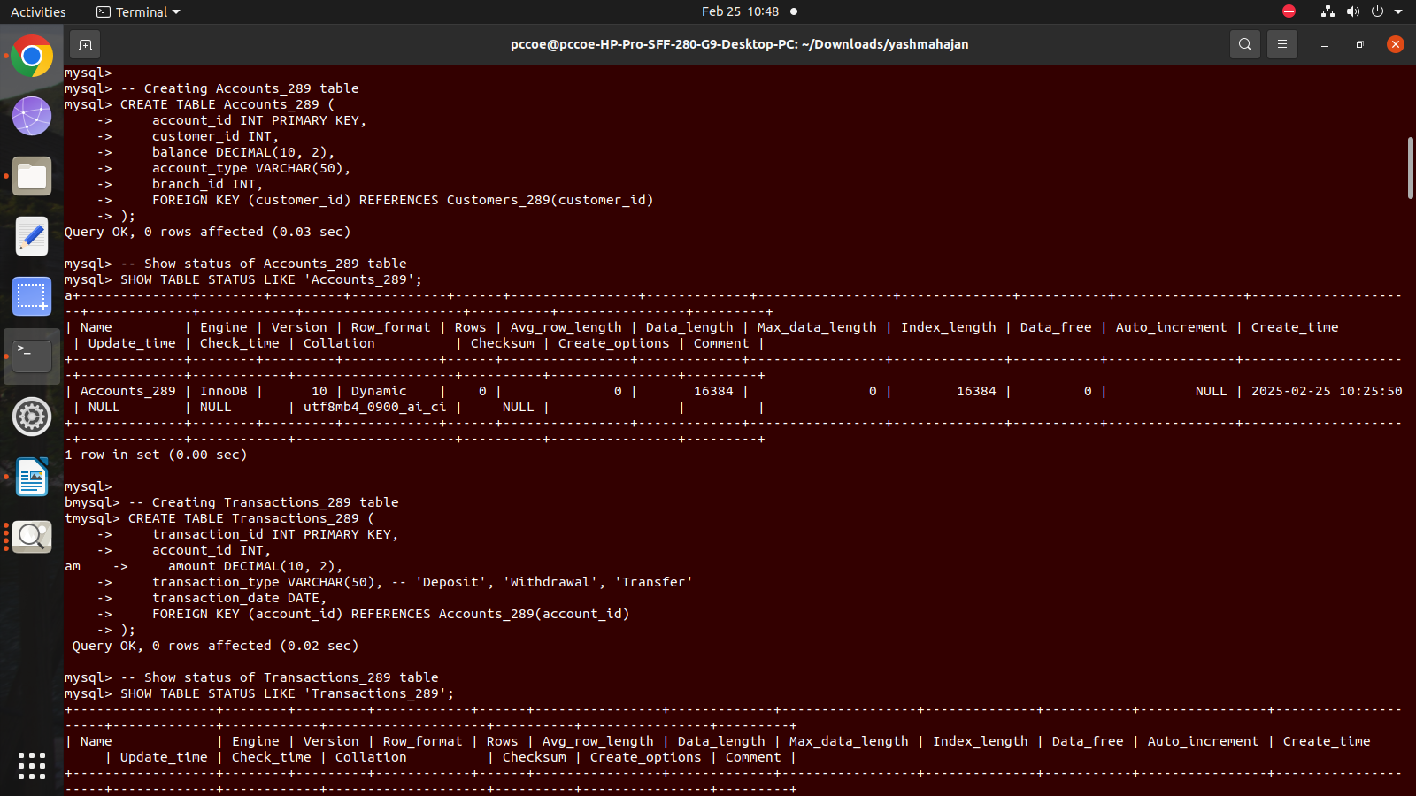

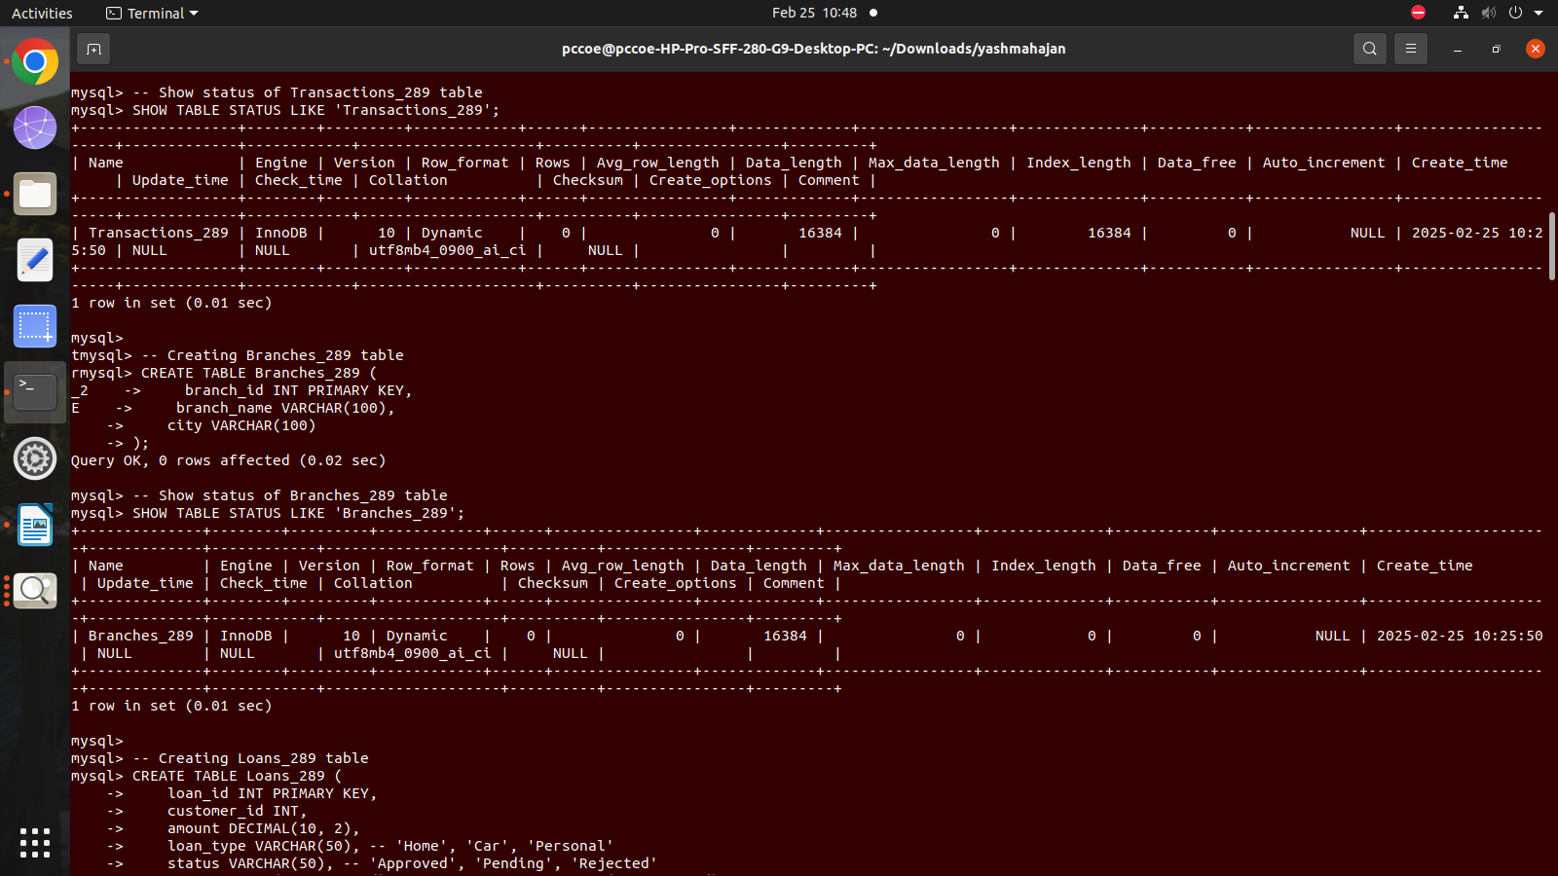

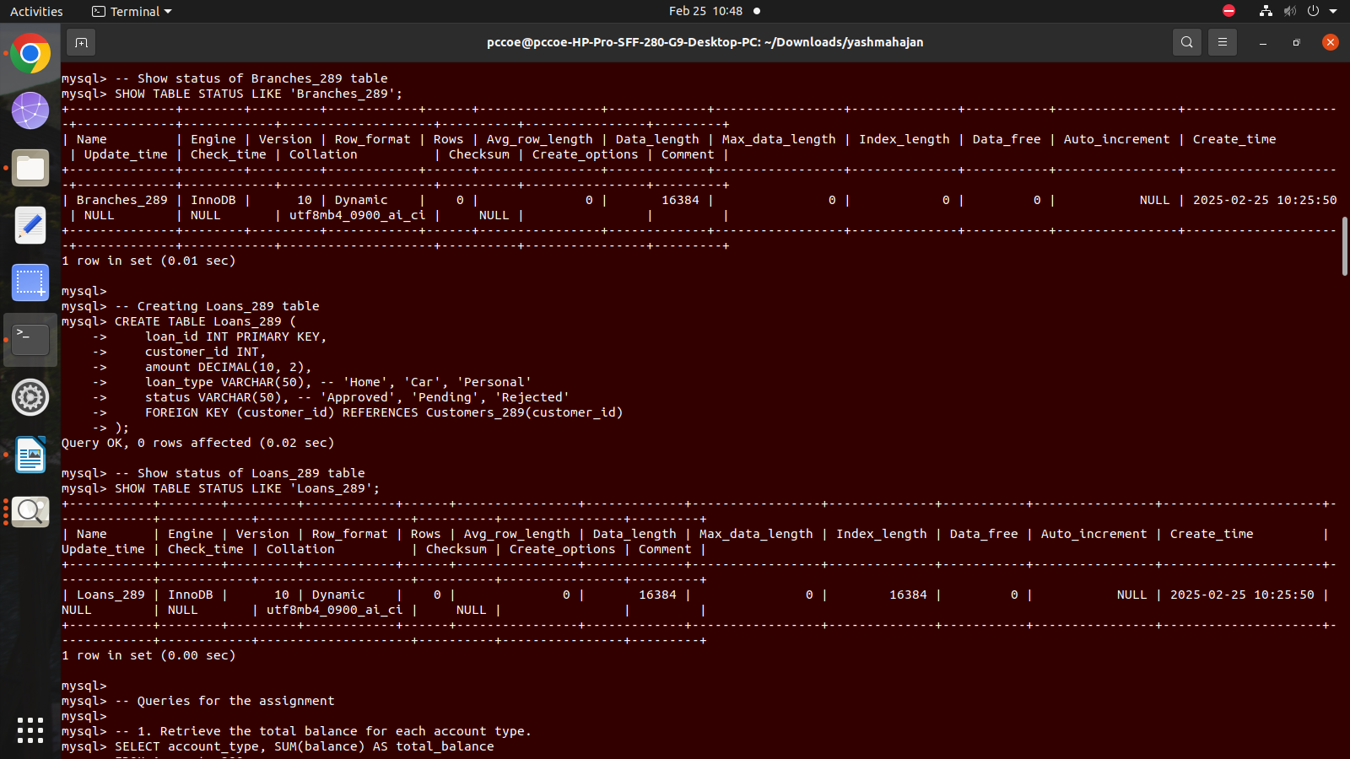

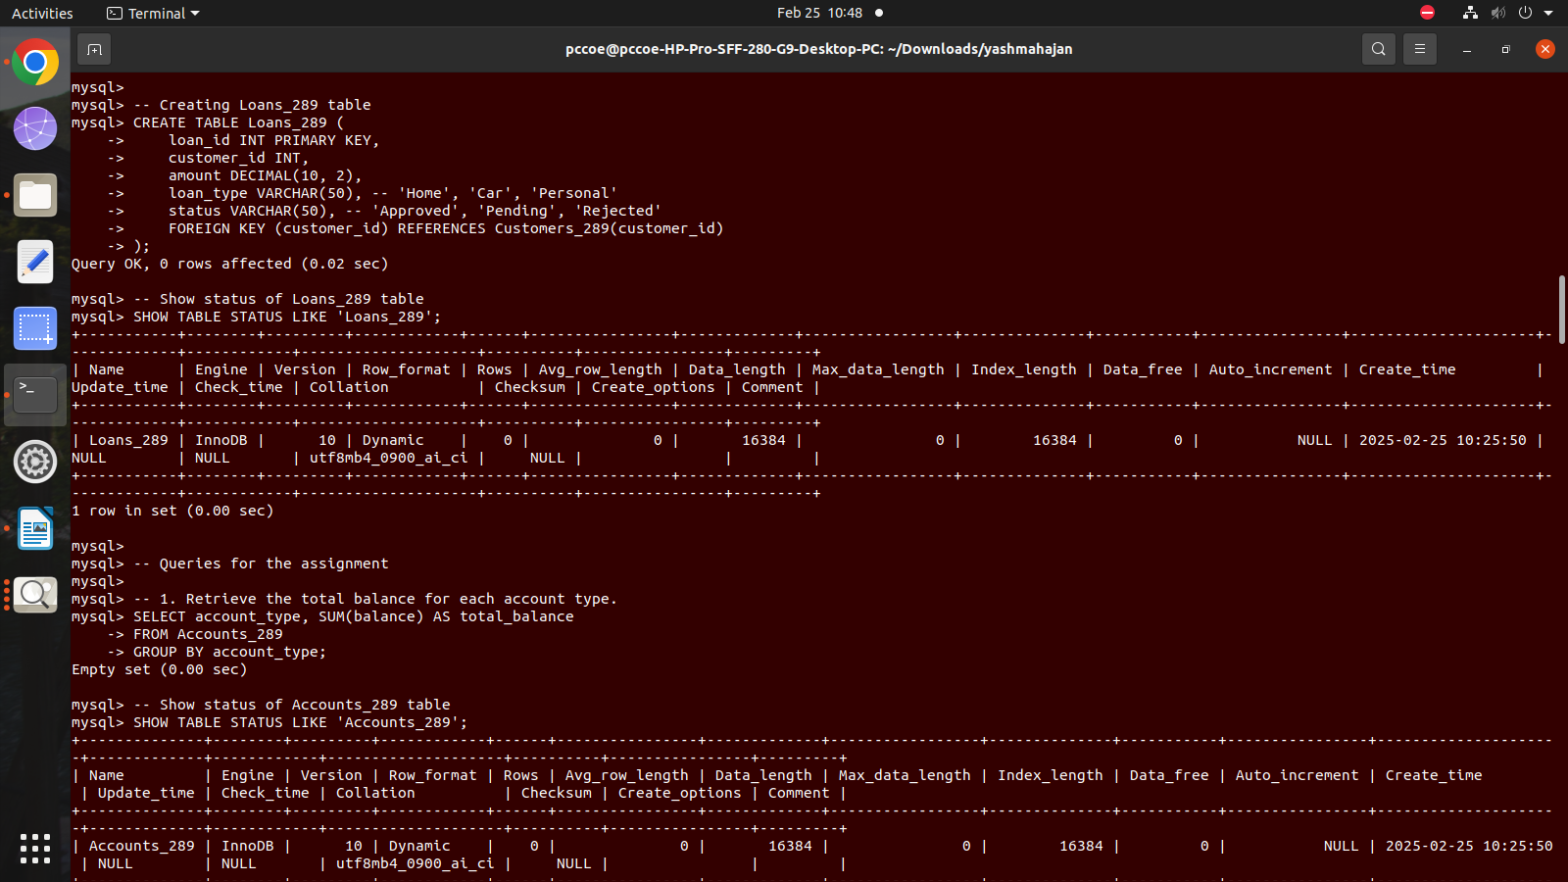

Solve following queries :
1. Retrieve the total balance for each account type.

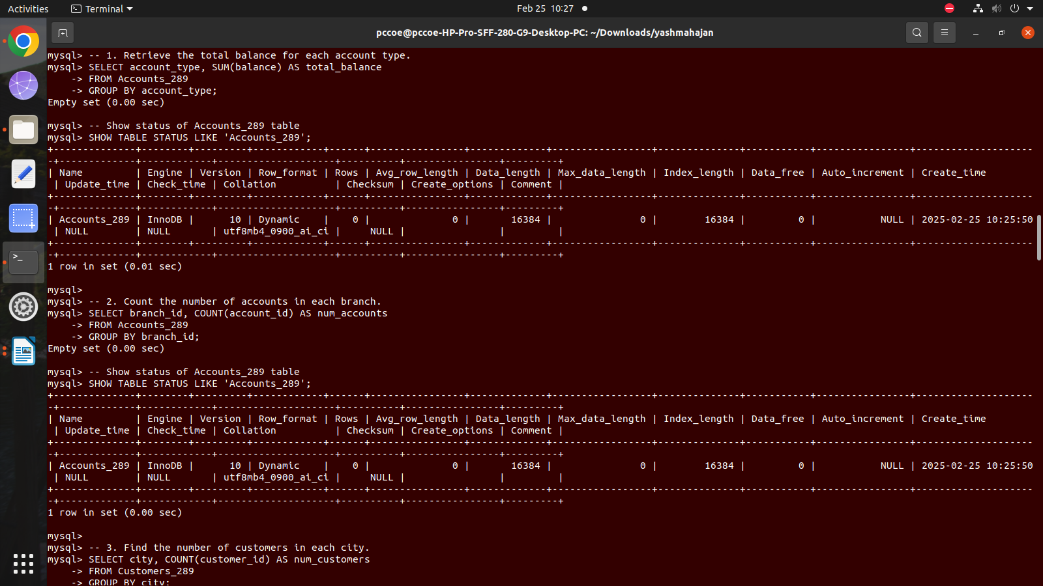
2. Count the number of accounts in each branch.


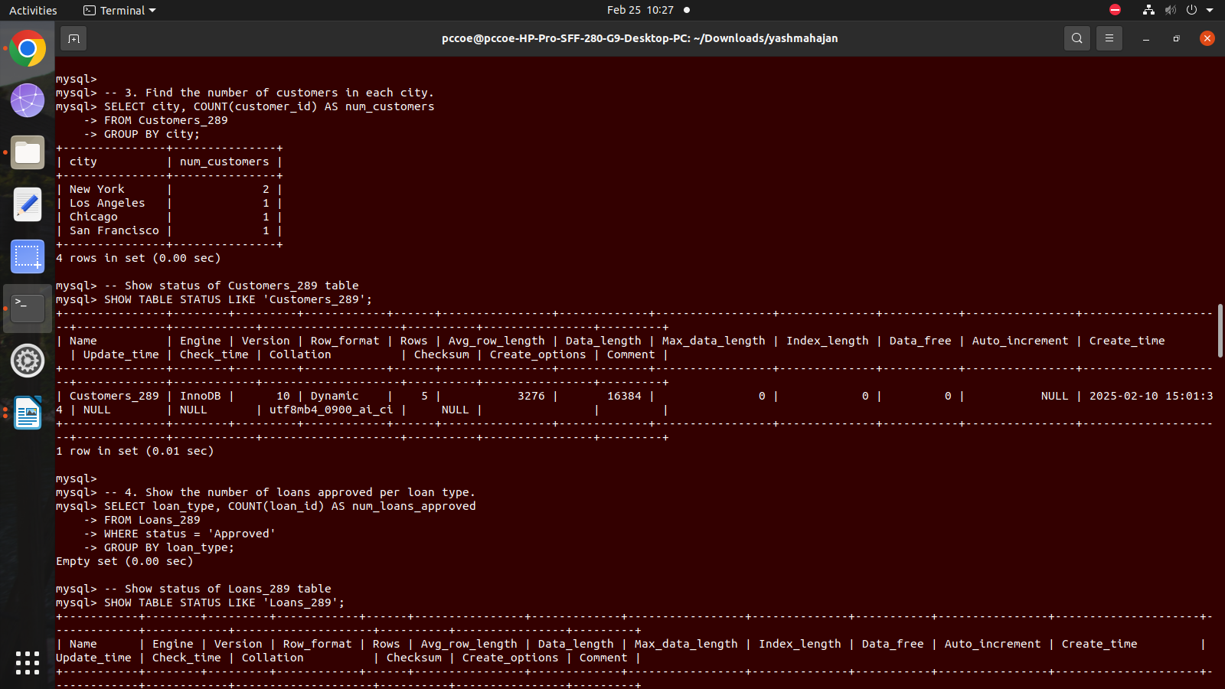
3. Find the number of customers in each city.
4. Show the number of loans approved per loan type.

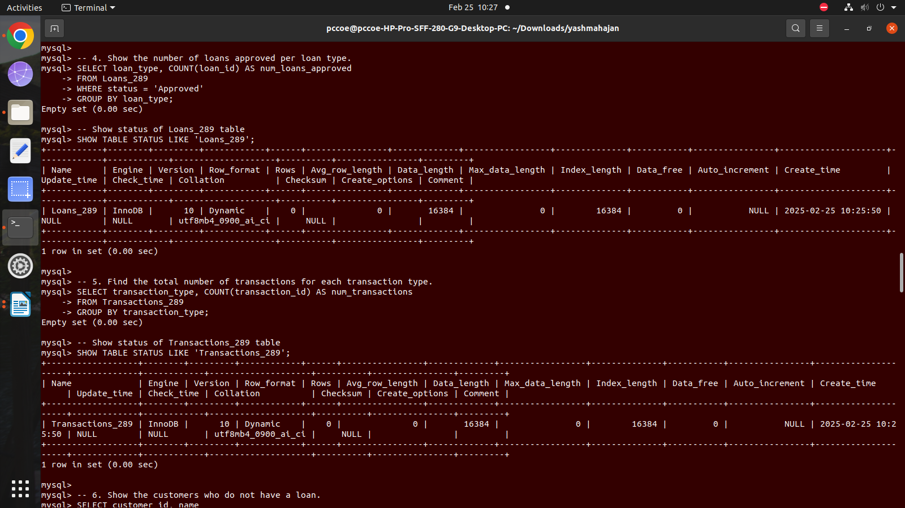

5. Find the total number of transactions for each transaction type.


6. Show the customers who do not have a loan.
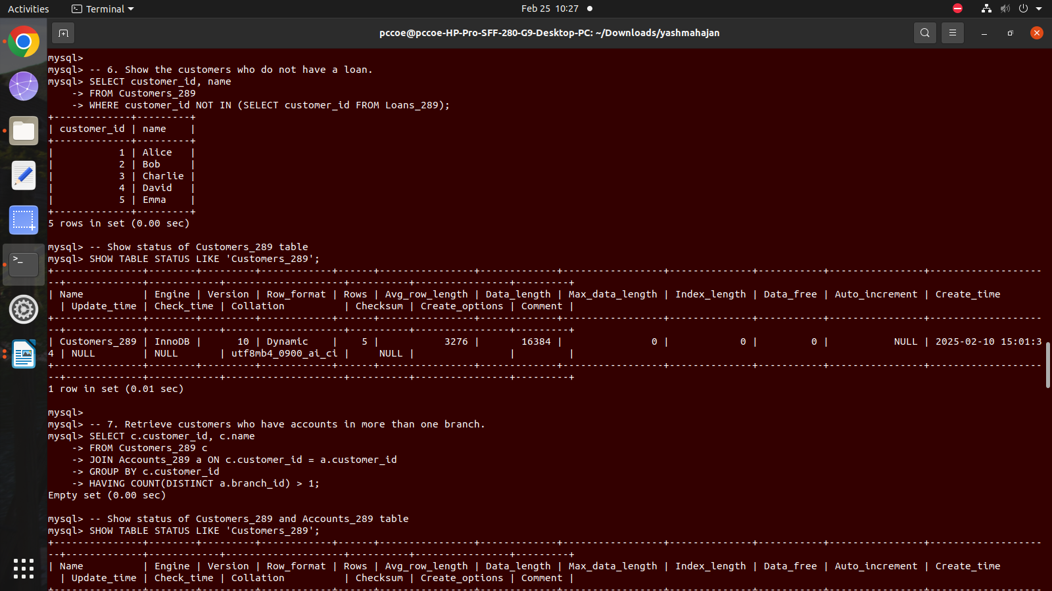

7. Retrieve customers who have accounts in more than one branch.

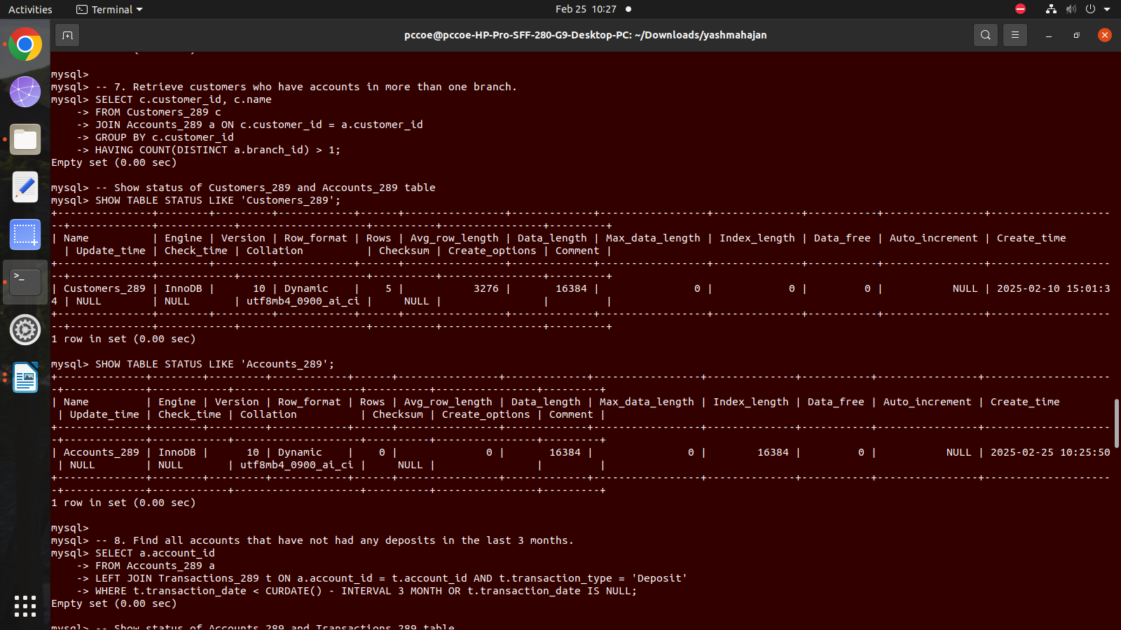

8. Find all accounts that have not had any deposits in the last 3 months.
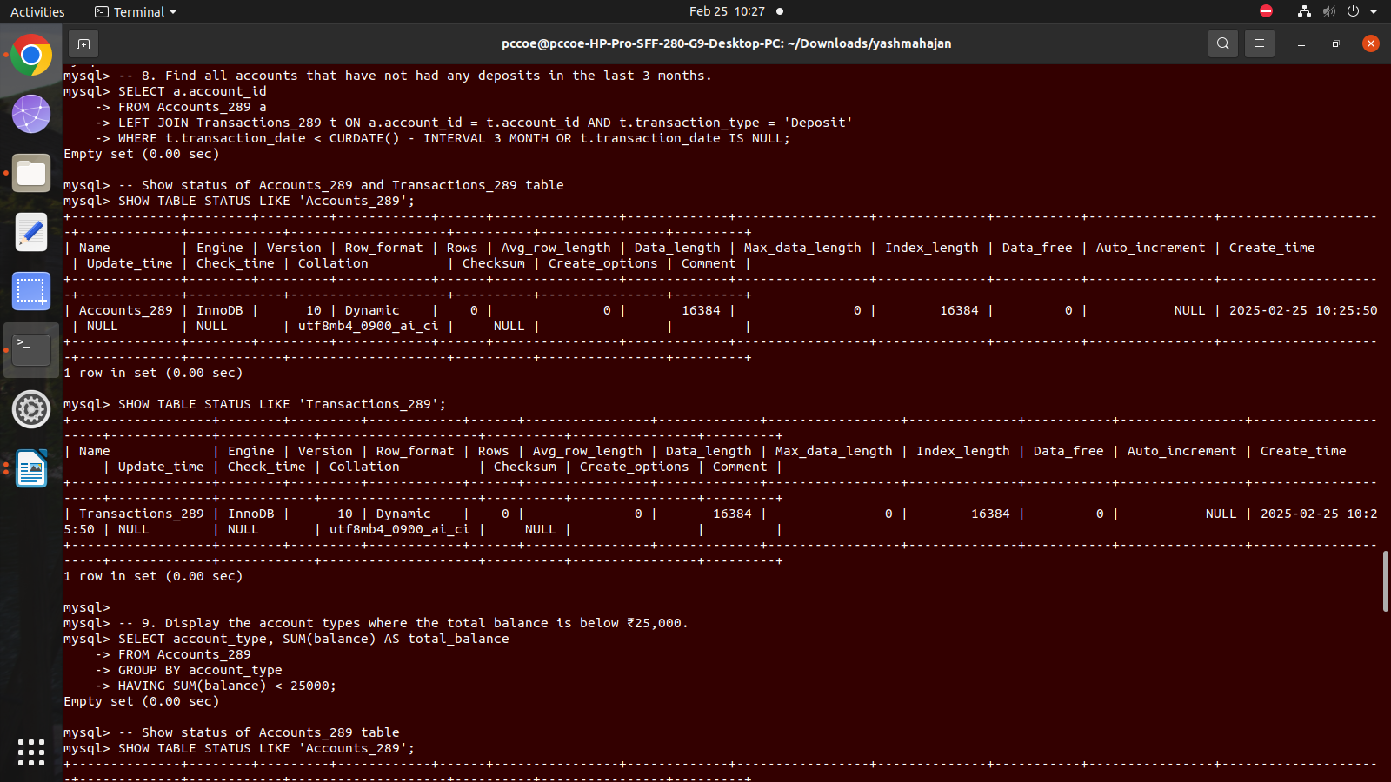

9. Display the account types where the total balance is below ₹25,000.
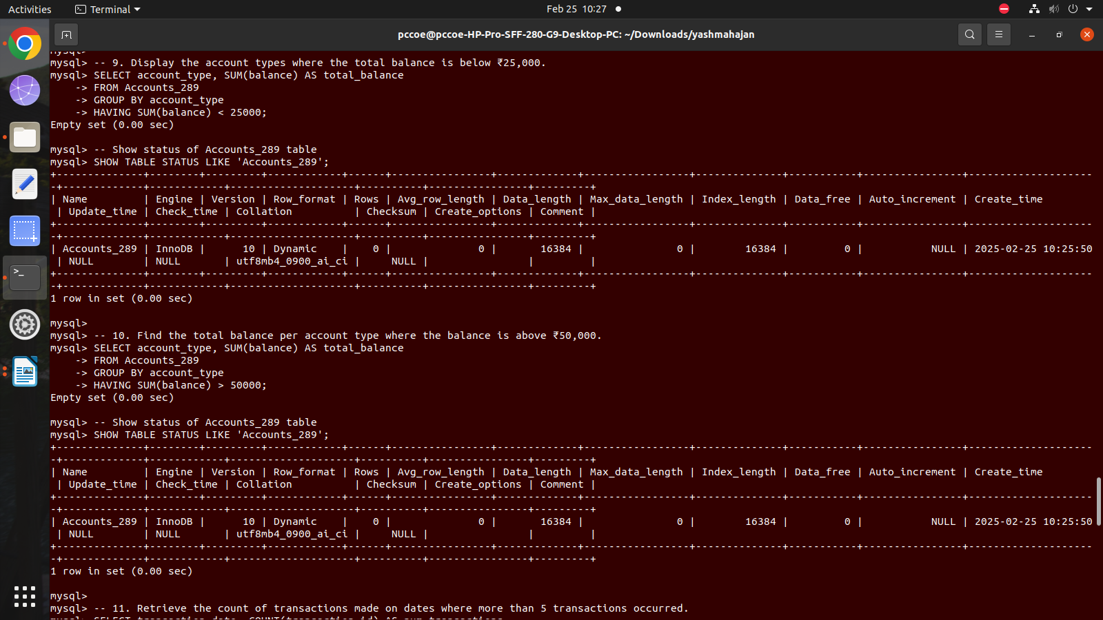


10. Find the total balance per account type where the balance is above ₹50,000.

11. Retrieve the count of transactions made on dates where more than 5 transactions occurred.
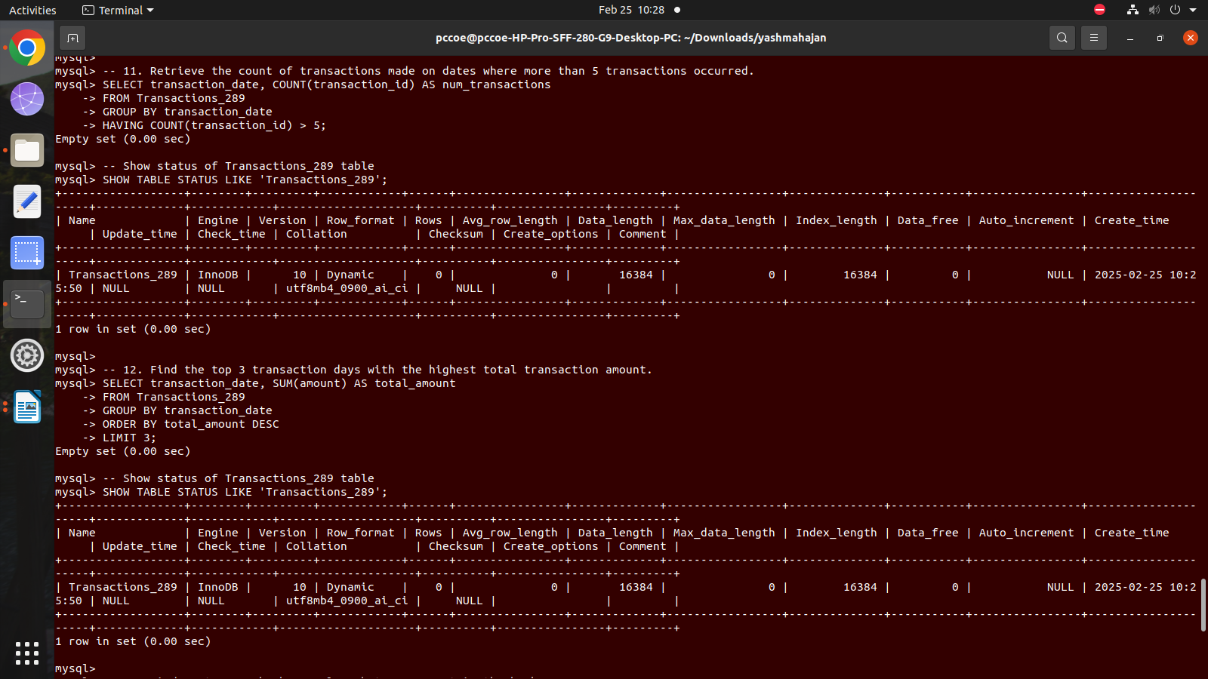

12. Find the top 3 transaction days with the highest total transaction amount.\

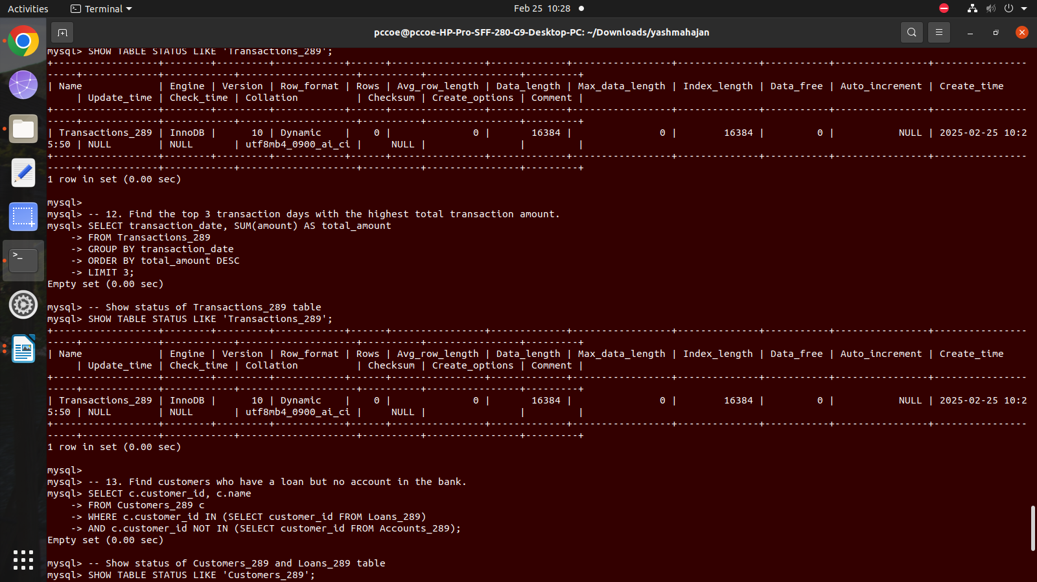

13. Find customers who have a loan but no account in the bank.

